Q1.
- A file is an ordinary file or a directory file.
Ans : Generalization
- Files contain records.
Ans : Composition
- A relation can be association or generalization.
Ans : Generalization
- A polygon is composed of an ordered set of points.
Ans : Aggregation
- A Person uses a computer language on a project.
Ans : Association

Q2
- An employee is either a full-time employee, a part-time employee, or an intern employee (Student employee)

- A University consists of Colleges, which in turn consist of Departments.
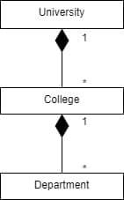
- A Seminar is given by at least two speakers and managed by a coordinator.
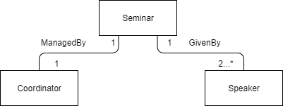
- A driver may own cars that can be driven by authorized drivers.
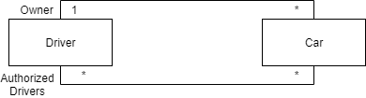

Q3
- Person class, Team class, and Conference class, they are all somehow related to each other by N-ary relation, but also they are all related into turnary or more than that. Also, the more details are available in AssignedStadium object.

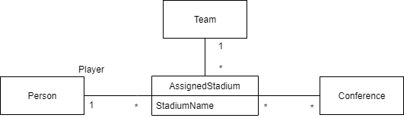
- The N-ary association is a good way of expression to show that the Classes in the N-ary association are related with each other. However, the problem is that we are hard to understand how they are related in detail. It is complicated. So by promoting into a class, we can understand it much easier.
- It does not change. Just the expression is changed while the meaning of it is basically same.

Q4

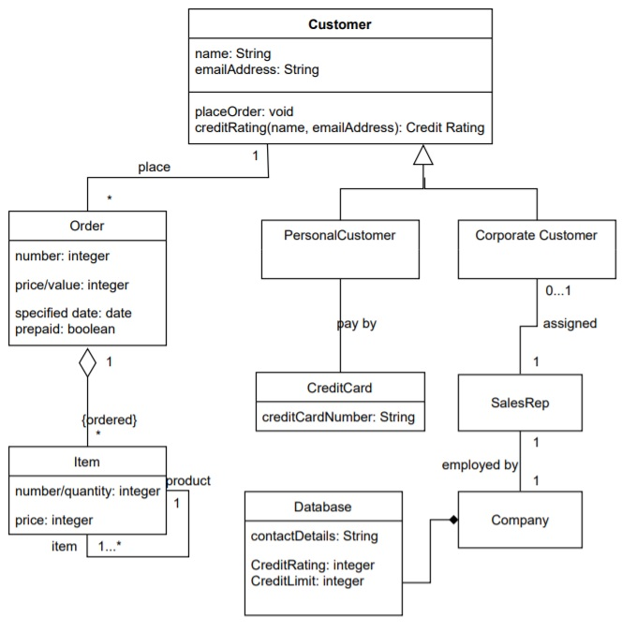
Q5
A Person who might be isMarried or be isUnemployed. Each Person is with the specific birthDate and age as well. We can figure out the Person’s firstName and lastName, and sex too. Also, the income can be checked by the birthday date. Each Person may be a customer of a Bank which has its own accountNumber as Integer. The Person may be a manager who managedCompanies and mange any number of Companies. Each Company is with its own name, numberOfEmployees, and its own stockPrice as well. On the other hand, each Company may have any number of employees who are Person. If it is so, there are their own Job which is with its own title, startDate, and salary. Each Person may be a wife or not, or a husband or not. If each Person is a husband or wife, they have Marriage, which is with the its own place, and the specific date.

